12 CUPS OF GRACE

Dara V. Rose
Author & Speaker Bio
Christian Author • Bible Teacher • Speaker
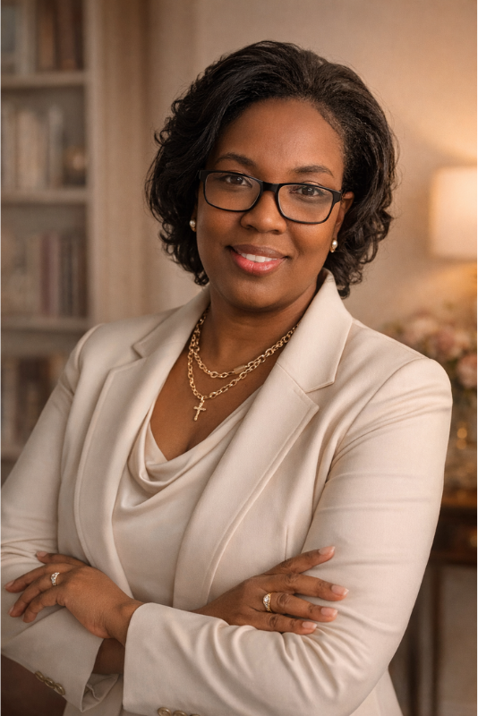
Dara V. Rose is a Christian author, Bible teacher, speaker, and founder of 12 Cups of Grace. She helps people slow down, understand Scripture, and recognize God’s presence in everyday life. Her memoir, Born for This Name: A Journey Through Family, Faith, and Finding My Voice, explores her personal experiences with grief, healing, and identity in Christ.
Through honest storytelling and Scripture-centered teaching, Dara encourages others to bring their whole story to God. She creates Bible studies and reflective experiences that make room for questions and spiritual growth. Her message is simple: You are not alone, and your story matters. Dara lives in the Midwest with her family.
12cupsofgrace.com
info@12cupsofgrace.com

